**CODE 1**

**TASK 1**

You should spend about 20 minutes on this task.

You have received the following email from your English-speaking friend, Jo, who invited you to visit her family. Read part of Jo’s letter.

“*I’ve thought about some things we could do while you’re here. First we’ll have lunch at home. Then in the afternoon we could either go on a habour trip with my family, or we could go shopping. Which would you prefer?*

*There isn’t much to do in my town in the evenings, so we could just stay at my home. Can you think of some things you’d like to do there?*

*Please let me know if there is anything else you need to know before you come.”*

Write an email responding to Jo. You should write at least 120 words. You are not allowed to include your name.

**TASK 2**

You should spend about 40 minutes on this task.

Read an extract from a book.

*“Of all the creative arts, music is probably the most popular. For some people, nothing is more beautiful than an opera, or a symphony by Beethoven or Mozart. Classical music is indeed the choice of millions. Yet others do not favour classical music and prefer jazz, rock, folk, country, or hip-hop. Music taste is in the ear of listeners.”*

*(Adapted from Mosaic 2, Reading, Page 246)*

Write an essay to an educated reader on the reasons why people need music.

Give reasons for your answers and include any relevant examples from your own knowledge or experience.

You should write at least 250 words.

**CODE 2**

**TASK 1**

You should spend about 20 minutes on this task.

You have received an email from your Scottish friend, Deborah. Read part of Deborah’s email.

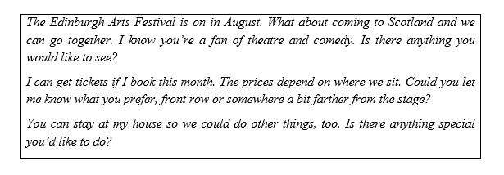

Write an email to Deborah. You should write at least 120 words. You are not allowed to include your name.

**TASK 2**

You should spend about 40 minutes on this task.

Read an extract from a book.

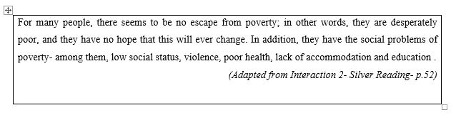

Write an essay to an educated reader on the solutions to poverty.

Give reasons for your answers and include any relevant examples from your own knowledge or experience.

You should write at least 250 words.

**CODE 3**

**TASK 1**

You should spend about 20 minutes on this task.

You are going to take part in an exchange programme in the summer. Read part of the letter from your host family below.

|  |
| --- |
| *Will you be arriving on June 30th and will stay until July 15th as planned?*  *There are two spare rooms and you can choose which one you’d prefer. The larger room downstairs has a door into the garden. The smaller room is in the attic with a window overlooking the river.*  *My wife would like to know if there is any food that you don’t eat. If there is anything else we can do to make your stay more comfortable, don’t hesitate to let us know.* |

Write a letter responding to Mr. Graham. You should write at least 120 words. You are not allowed to include your name.

**TASK 2**

You should spend about 40 minutes on this task.

Read the following text from a book.

|  |
| --- |
| Americans are worried about new technology. They are concerned that machines, including robots, will take over work now done by humans. And they expect automation to be so common in America that people will face difficulty finding things to do with their lives. These findings come from a new report by the Pew Research Center of Washington D.C.  *(Adapted from https://learningenglish.voanews.com)* |

Write an essay to an educated reader to discuss your opinion over the posibility of unemployment due to new technology.

Give reasons for your answers and include any relevant examples from your own knowledge or experience.

You should write at least 250 words.